Agricultural AI for Smart Farming
Ch. Surya (2420090001), V. Rithwik (2420090037), P. Akshya (2420030628), B. Niharika (2420030601), and K. Swanthana (Faculty)
Department of Computer Science and Engineering
Koneru Lakshmaiah Education Foundation, Bowrampet, Hyderabad-500043, Telangana, India
Abstract—Farming decisions such as crop choice, irrigation timing, and disease response still depend largely on experience and manual observation, although soil, weather, and plant health change continuously. Practical decision support should provide predictions for several tasks, reject unsuitable inputs, be usable in local languages, and be evaluated without overstating what the data show. This paper presents a web-based machine-learning platform for four tasks: crop recommendation, leaf-disease classification, irrigation-need estimation, and crop-yield forecasting. Leaf photographs pass a vegetation-ratio filter and a blur filter before classification. Five classical algorithms (Decision Tree, Random Forest, SVM, XGBoost, LightGBM) are compared per task under one evaluation protocol. On the 22-class crop task, Random Forest reached 99.55% accuracy; on the 32-class disease task, it reached 97.81%. For regression, XGBoost gave the lowest errors: 1.65 mm for irrigation and 1.35 quintals per acre for yield. The platform (React, FastAPI, PostgreSQL; English, Telugu, Hindi) passed all 42 automated end-to-end and integration tests. These are results on curated or project datasets, not field trials: sensor readings were simulated, irrigation labels follow FAO-56 relationships, and field validation, per-class error analysis, and cross-region testing are identified as required follow-up work rather than completed findings.
Index Terms—smart farming, precision agriculture, crop recommendation, plant disease classification, irrigation estimation, yield forecasting, Random Forest, XGBoost, reproducibility

I. INTRODUCTION
Farming depends on many interacting factors: soil fertility, rainfall, temperature, humidity, water supply, crop variety, and plant health. Choosing a crop, deciding when to irrigate, and reacting to early signs of disease all affect yield and the use of water and fertilizer. Field inspection by eye remains valuable, but it is time-consuming, difficult to repeat over large areas, and many small farmers have limited access to an agronomist when they need one.
Machine learning (ML) can learn patterns from past agricultural records, and image classification can recognize symptoms visible on a leaf. Earlier studies have applied ML to crop recommendation and farm management [1]–[3]. In most of them, however, crop choice, disease identification, irrigation planning, and yield estimation are treated as separate problems with separate tools and data. Predictive accuracy alone also does not tell a user whether an input was valid, whether the data resemble real field conditions, or which parts of a system were actually tested.
This paper therefore documents a platform and its current evidence without conflating curated-dataset results with field performance, and without claiming that unvalidated modules have been validated. The paper makes five contributions:
- A modular design for four prediction tasks, plus fertilizer, weather, and market-price services, with data, models, and evaluation kept separate for each task.
- A side-by-side comparison of five classical ML algorithms under one evaluation protocol per task, reporting the metrics actually recorded in the project.
- Image-validation filters that reject non-plant and blurry photographs before disease classification.
- Access in English, Telugu, and Hindi, including spoken output through the browser.
- A testing and evidence record that separates verified results from simulated components, together with a validation protocol for the experiments still required.
II. RELATED WORK
A. Crop Recommendation and Farm Management
Supervised learning has been applied to soil and climate variables to suggest suitable crops. One recommendation system for Indian agriculture draws on soil, climate, and related data to support crop selection [1], and another study applies ML methods to crop selection under changing environmental conditions [3]. Other work places ML inside smart farm management, including data-driven crop management and resource allocation [2]. These studies motivate comparing several algorithms rather than settling on one early. Their reported results are not compared numerically with ours, because datasets, class sets, splits, and metric definitions may differ.
B. Plant Disease Classification
The PlantVillage collection of labelled leaf images [5] is widely used to train and test disease classifiers. Its images are captured under controlled conditions, so accuracy on such data does not by itself indicate accuracy on field photographs, where lighting, background, and camera quality vary.
C. Tabular Learners
Ensemble tree methods such as Random Forest [6] and gradient-boosting libraries such as XGBoost [7] and LightGBM [8] are common choices for tabular prediction. They train quickly on modest hardware, which suits a platform intended for low-resource deployment, although a strong score on one dataset does not establish generalization to another region or season.
D. Irrigation and Yield Estimation
The FAO-56 guidelines [9] define the standard way to compute crop evapotranspiration and crop water requirements and give an irrigation module a sound physical basis. If model labels are themselves generated from such relationships, a high fit shows that the formulation is reproduced, not that independently measured field water need is predicted.
E. Research Positioning
A recurring problem is that datasets differ in crops, regions, collection methods, and labels, so a model trained on one cannot be assumed to work on another or on a real farm. The platform is positioned as a prototype that integrates four tasks, input validation, and local-language access, and that reports its evidence transparently. The current results do not establish that it outperforms published systems; such a claim would require implementation-level comparison on a shared dataset and protocol.
III. DATASET AND PROBLEM DEFINITION
A. Dataset Snapshot
Table I summarizes the data used for each task. Crop recommendation uses the public Crop Recommendation dataset [4] with 2,200 records and 22 crop classes, and the features N, P, K, temperature, humidity, pH, and rainfall. Disease classification uses a 32-class leaf-image collection derived from PlantVillage-type data [5]. Irrigation and yield modules were trained and tested on project datasets because independent field-measured records were not available.
TABLE I. DATA USED FOR EACH TASK.
Task | Source | Size / target | Status
Crop | Public dataset [4] | 2,200 records; 22 classes; 7 features | Curated
Disease | PlantVillage-type [5] | [image count]; 32 classes | Curated images
Irrigation | Project dataset | [records]; mm and urgency class | Labels follow FAO-56 [9]
Yield | Project dataset | [records]; quintals/acre | Not field-measured

Before publication, the exact data release, license or terms of use, record and image counts, class balance, duplicate policy, and checksum for each dataset should be stated. The sensor dashboard uses a microclimate simulation and is not a data source for any reported metric.
B. Task Formulation
Let xᵢ denote the input for sample i. For crop recommendation, xᵢ is a seven-dimensional vector and yᵢ is one of 22 classes. For disease classification, xᵢ is a leaf image and yᵢ is one of 32 classes. For irrigation, the target is a net water requirement in mm, and a derived urgency class is also assigned. For yield, the target is yield in quintals per acre. All four are single-label or single-value tasks; none is multi-label. Because the tasks differ, their metrics are reported separately and are not pooled.
C. Preprocessing and Data Leakage
Every input is checked for units and range, and missing or out-of-range values are rejected rather than imputed into a misleading recommendation. Scaling is applied only where the algorithm needs it (the SVM), and its parameters are fitted on training data alone. Within a task, all models share the same split and feature set. The split ratio and random seed were .
Two leakage risks need explicit audit before stronger claims are made. First, leaf-image collections often contain several photographs or augmented copies of the same leaf, which can fall on both sides of a random split. Second, where irrigation labels are computed from FAO-56 formulas using the same variables supplied as features, the task partly reduces to recovering a known formula. Neither check is documented in the current artifacts.
IV. PROPOSED PLATFORM
A. Technology Stack and Architecture
The frontend uses React 18 with Vite. The backend is a FastAPI service on Uvicorn with a PostgreSQL 15 database. Training and inference use Scikit-Learn, XGBoost, and LightGBM. Users authenticate with HS256-signed JSON Web Tokens, passwords are stored as Bcrypt hashes, and role-based access control (RBAC) keeps administrative endpoints from ordinary accounts. As Fig. 1 shows, a request passes from the web interface to the FastAPI layer, which authenticates the user and validates inputs, and then to the ML module for that task; the database and supporting services sit alongside. The diagram describes the design, not measured performance.
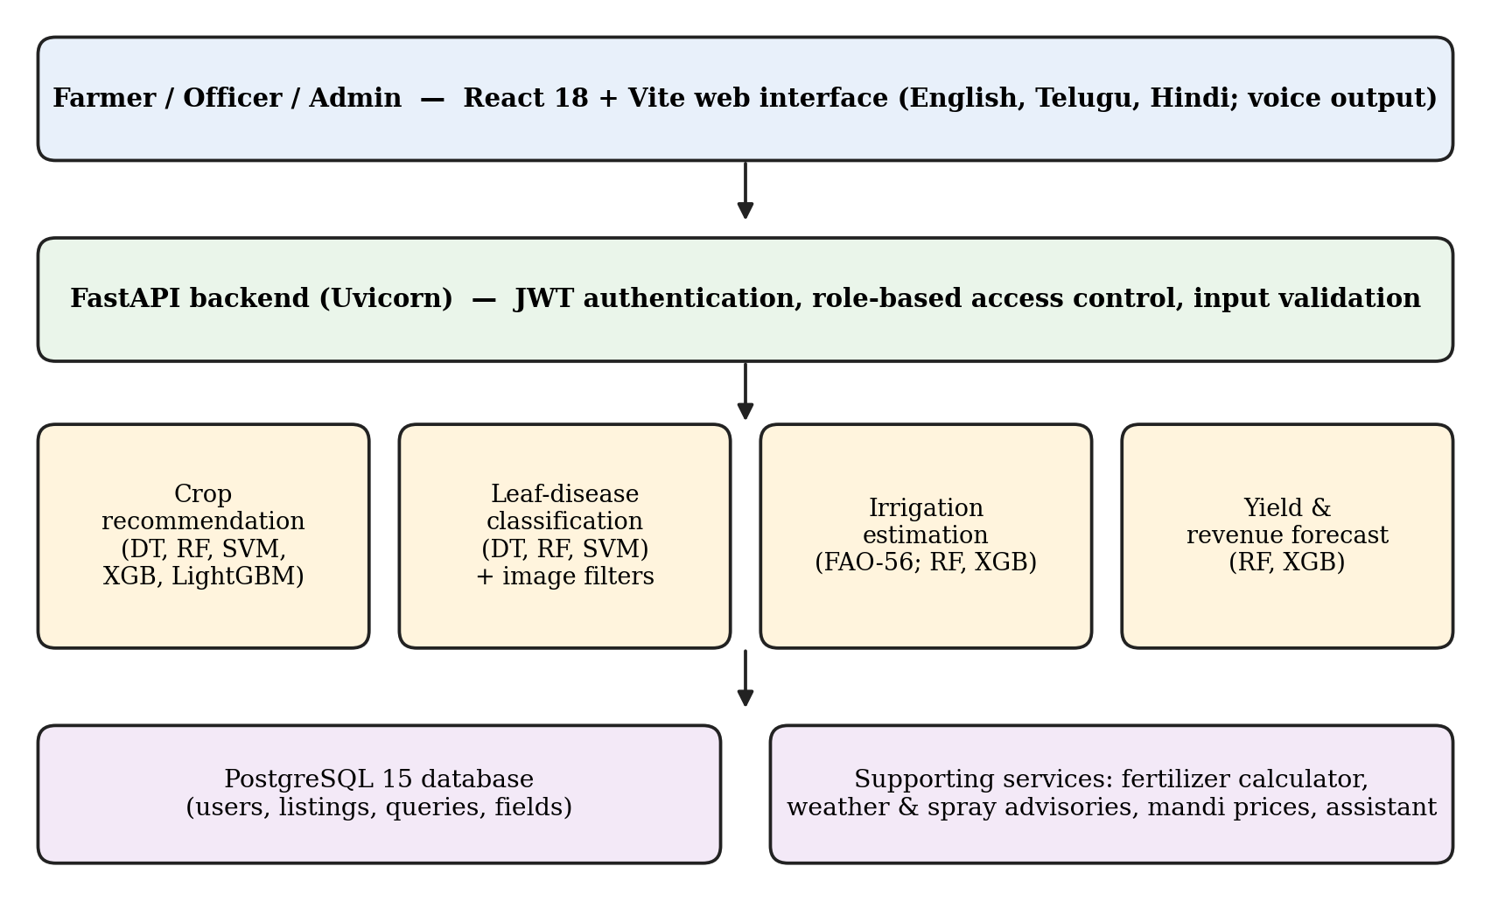
Fig. 1. Architecture of the proposed platform.
B. Prediction Modules
The crop module predicts a crop from N, P, K, soil pH, temperature, humidity, and rainfall. The disease module classifies an uploaded leaf image as healthy or as one of the disease classes and returns a confidence value with remedies in three languages. The irrigation module follows the FAO-56 approach to compute soil-moisture deficit and net water requirement, in mm and litres per acre, and assigns an urgency class. The yield module predicts yield in quintals per acre and an estimated gross revenue in Indian rupees.
C. Supporting Services
A fertilizer calculator converts NPK soil deficits into doses of Urea, DAP, MOP, and micronutrients in kg per acre. Other services are a 5-day weather and spray-advisory service, APMC mandi price listings with short trends, a marketplace for produce listings, and a ticket system in which farmers send queries that officers review and resolve. A multilingual assistant answers agronomy questions in English, Telugu, and Hindi, and responses can be read aloud through the browser speech-synthesis interface.
D. Image Validation
Each uploaded image passes two checks before classification. A vegetation-ratio filter rejects images in which the share of plant-coloured pixels is below 0.08, and the request fails with HTTP 400. A Laplacian edge-variance filter flags blurry images. Without these checks, the classifier could return a confident disease label for a photograph that is not a leaf. The false-rejection and false-acceptance rates of these filters have not been measured and are listed as future work.
V. EXPERIMENTAL SETUP AND METRICS
Five algorithms were trained for crop recommendation: Decision Tree, Random Forest, SVM, XGBoost, and LightGBM. Disease classification used Decision Tree, Random Forest, and SVM. Irrigation and yield used Random Forest and XGBoost regressors. Inference time for a single prediction was recorded. Latency depends on hardware, warm-up policy, and timing boundaries, so hardware and software versions should accompany the final artifacts .
The following metrics are used:
- Accuracy, precision, recall, F1: weighted averages across classes; F1 is the harmonic mean of precision and recall.
- MAE and RMSE: mean absolute and root mean square error, in mm (irrigation) or quintals per acre (yield).
- R²: coefficient of determination.
- Irrigation accuracy: share of samples assigned the correct urgency class.
- Yield accuracy (tolerance-based): share of predictions within 15% of the true value,
Acc_15 = (1/N) Σ I[ |ŷ_i − y_i| ≤ 0.15·y_i ] (1)
This measure is specific to this work and must not be compared directly with classification accuracy; it should be read together with MAE, RMSE, and R².
VI. IMPLEMENTATION
The SmartFarm-ML platform is implemented as a web-based machine learning decision-support system that integrates four major agricultural prediction modules: crop recommendation, leaf-disease classification, irrigation requirement estimation, and crop-yield forecasting. The system follows a modular architecture in which the frontend, backend, machine learning models, and database work together to process user inputs and generate predictions.
A. Frontend Implementation
The frontend is developed using React 18 with Vite to provide an interactive and responsive user interface. Farmers can enter soil and environmental parameters, upload leaf images, and access prediction results through the web application. The interface supports English, Telugu, and Hindi to improve accessibility for users from different linguistic backgrounds.
B. Backend Implementation
The backend is developed using Python and FastAPI, running through the Uvicorn server. It receives requests from the frontend, validates input data, communicates with the corresponding machine learning models, and returns prediction results. PostgreSQL 15 is used for database management. Authentication is implemented using JSON Web Tokens (JWT), password hashing with Bcrypt, and Role-Based Access Control (RBAC).
C. Crop Recommendation Module
The crop recommendation module uses seven input parameters: Nitrogen (N), Phosphorus (P), Potassium (K), temperature, humidity, soil pH, and rainfall. The dataset contains 2,200 records belonging to 22 crop classes. Five machine learning algorithms, namely Decision Tree, Random Forest, Support Vector Machine (SVM), XGBoost, and LightGBM, are evaluated. Random Forest achieves the highest recorded accuracy of 99.55%. The module generates a suitable crop recommendation based on the provided agricultural parameters.
D. Leaf-Disease Classification Module
The leaf-disease classification module identifies plant diseases using uploaded leaf photographs. The system uses a 32-class leaf-image dataset derived from PlantVillage-type data. Before classification, images pass through two validation stages: a vegetation-ratio filter to reject non-plant images and a Laplacian edge-variance filter to identify blurry images. The validated image is processed by the classification model, which returns the predicted disease class and confidence value. Random Forest achieves a recorded accuracy of 97.81%. Disease information and remedies are provided in English, Telugu, and Hindi.
E. Irrigation Requirement Estimation Module
The irrigation module estimates the amount of water required for crops based on agricultural and environmental parameters. It follows the FAO-56 approach to calculate soil-moisture deficit and net water requirements. Random Forest and XGBoost regression models are used for prediction. The output includes estimated water requirements in millimetres and litres per acre, along with an irrigation urgency category. XGBoost achieves a recorded MAE of 1.65 mm and RMSE of 2.48 mm.
F. Crop-Yield Forecasting Module
The crop-yield forecasting module estimates agricultural production using project-dataset inputs related to crop and environmental conditions. Random Forest and XGBoost regression algorithms are implemented and evaluated. The predicted yield is expressed in quintals per acre, with an estimated gross revenue in Indian rupees. XGBoost achieves a recorded MAE of 1.35 quintals per acre and an R² score of 0.948.
G. Supporting Services and Multilingual Assistant
In addition to the four prediction modules, the platform incorporates supporting agricultural services. These include a fertilizer calculator for Urea, DAP, MOP, and micronutrients, a five-day weather and spray-advisory service, agricultural market-price listings, a produce marketplace, and a farmer query-management system. A multilingual assistant provides agricultural information in English, Telugu, and Hindi. Browser-based speech synthesis is used to read responses aloud.
H. Database Integration and Security
PostgreSQL 15 is integrated with the backend to manage application information, including user accounts and platform records. JWT-based authentication verifies user sessions, while Bcrypt protects stored passwords. RBAC restricts administrative operations to authorized users. Input validation is applied to prevent missing, invalid, and out-of-range values from entering the prediction pipeline.
I. System Integration and Testing
All frontend components, backend APIs, database operations, and machine learning modules are integrated into a single web-based platform. The system is evaluated using 42 automated scenarios, consisting of 11 end-to-end tests and 31 integration tests. These tests cover API communication, database operations, authentication, access control, machine learning pipelines, image validation, multilingual functionality, and supporting services. All 42 recorded tests passed, and the TypeScript production build completed without compiler errors.

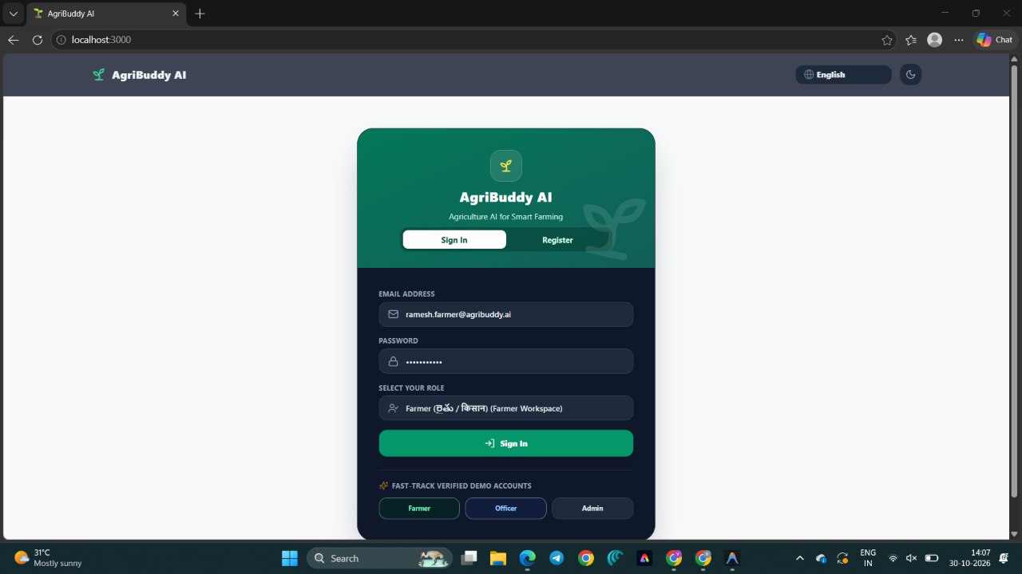
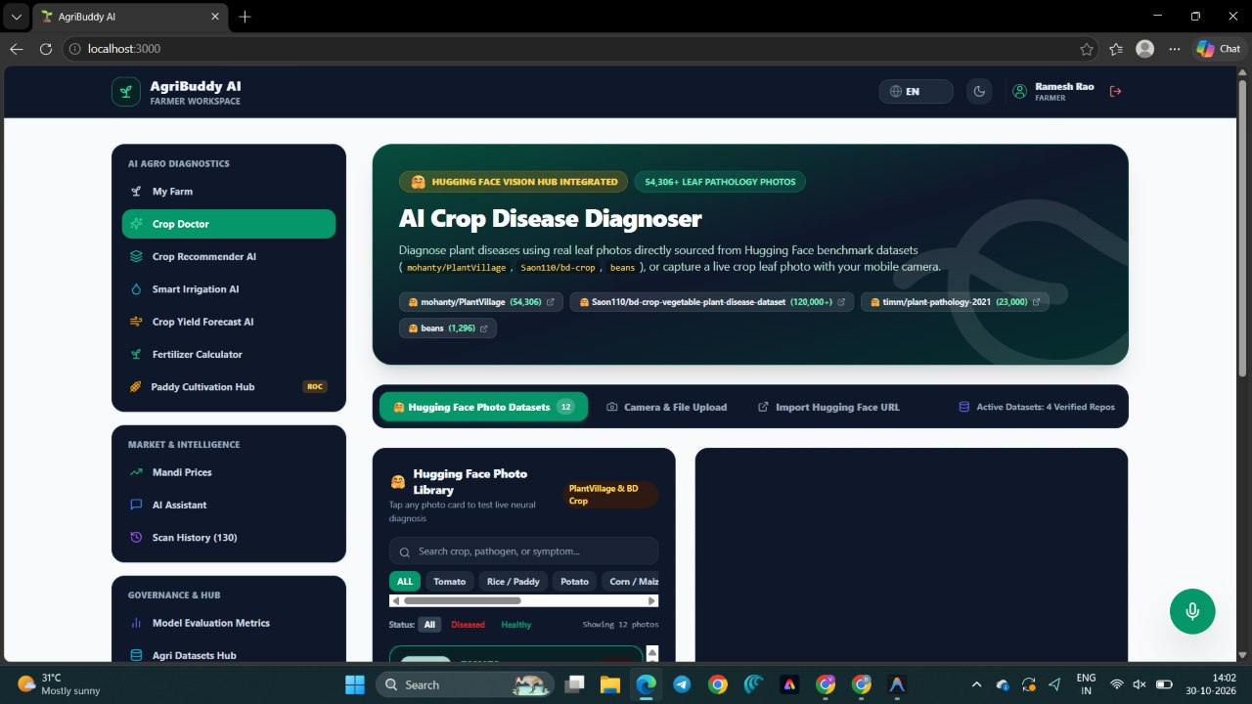
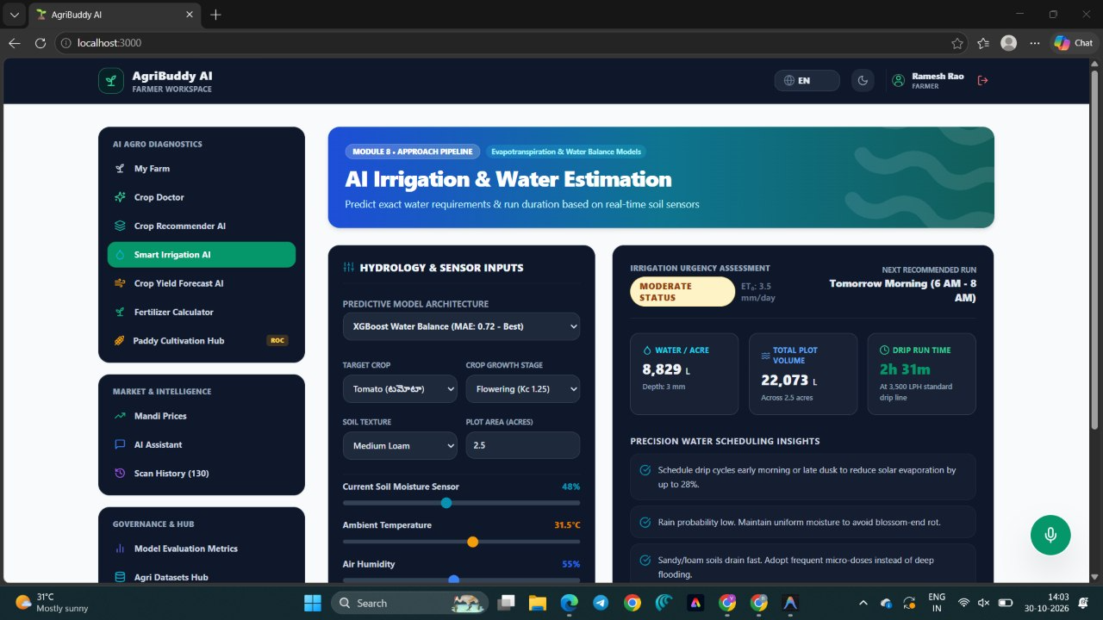
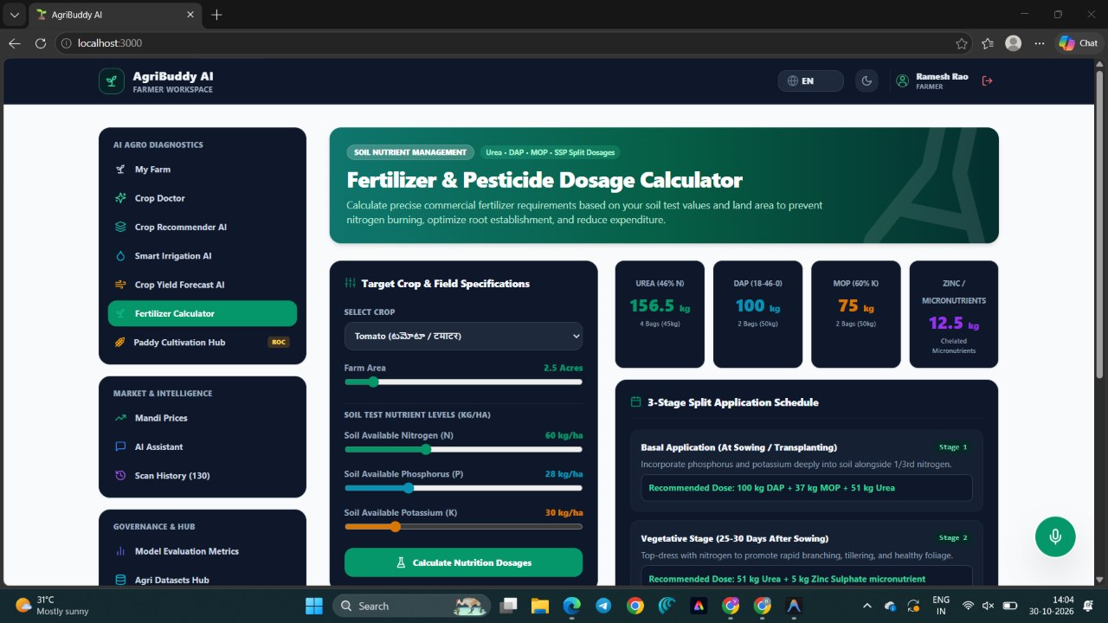

VII. RESULTS
All values below are recorded values from the project runs and have not been independently reproduced for this paper.
A. Crop Recommendation
Table II gives the results on the 22-class crop task. Random Forest was most accurate at 99.55%; LightGBM and XGBoost followed at 99.09%, Decision Tree reached 98.64%, and SVM was lowest at 97.95%. The best-to-worst gap is under two percentage points. Inference times ranged from 0.02 ms (Decision Tree) to 0.12 ms (Random Forest). As a functional check, the input N = 90, P = 42, K = 43 returned Rice, with a 95% score from Random Forest and 99% confidence from LightGBM.
TABLE II. CROP RECOMMENDATION (22 CLASSES, 2,200 RECORDS).
. Leaf-Disease Classification
Table III covers the 32-class disease task. Random Forest reached 97.81%, SVM 96.88%, and Decision Tree 94.27%. All three responded in under 0.15 ms. Because curated images differ from field photographs in lighting, background, and camera quality, these numbers describe dataset performance, not field accuracy. A per-class confusion analysis has not been done.
TABLE III. LEAF-DISEASE CLASSIFICATION (32 CLASSES).
Algorithm | Acc. (%) | Prec. (%) | Rec. (%) | F1 (%)
Random Forest | 97.81 | 97.85 | 97.81 | 97.82
SVM | 96.88 | 96.94 | 96.88 | 96.89
Decision Tree | 94.27 | 94.35 | 94.27 | 94.29

C. Irrigation and Yield Estimation
Table IV gives the regression results. For irrigation, XGBoost outperformed Random Forest with MAE 1.65 mm versus 1.82 mm, RMSE 2.48 mm versus 2.64 mm, and R² 0.982 versus 0.978. For yield, XGBoost reached MAE 1.35 and R² 0.948, against 1.42 and 0.941 for Random Forest. The two models are close, so interpretability and deployment cost could reasonably decide between them.
TABLE IV. IRRIGATION AND YIELD REGRESSION.
Task / Model | Acc. (%) | MAE | RMSE | R²
Irrigation – RF | 96.40 | 1.82 | 2.64 | 0.978
Irrigation – XGB | 96.80 | 1.65 | 2.48 | 0.982
Yield – RF | 94.20 | 1.42 | 2.15 | 0.941
Yield – XGB | 94.80 | 1.35 | 2.08 | 0.948
MAE/RMSE in mm (irrigation) and quintals per acre (yield). Yield accuracy is the share within 15% of the true value.
Because the irrigation module is built on FAO-56 relationships, a high R² shows that the model reproduces that formulation, not that it predicts independently measured water need. Likewise, yield results come from project datasets, not recorded farm outcomes.
D. System Testing
The platform was tested with 42 automated scenarios: 11 end-to-end and 31 integration tests covering API contracts, database operations, RBAC, ML pipelines, image validation, the multilingual assistant, and the market-price service. All 42 passed after fixes, and the TypeScript production build completed without compiler errors. Testing exposed five defects: a missing property in a TypeScript user type, a console encoding error printing Telugu and Hindi on Windows, a missing weather endpoint, a field-sensor endpoint using an undefined model and a wrong attribute name, and a marketplace schema that rejected alternative field names. Each was traced and fixed. Access control behaved as intended: a farmer account requesting administrator statistics received HTTP 403. These tests verify software behaviour, not the agronomic correctness of predictions.

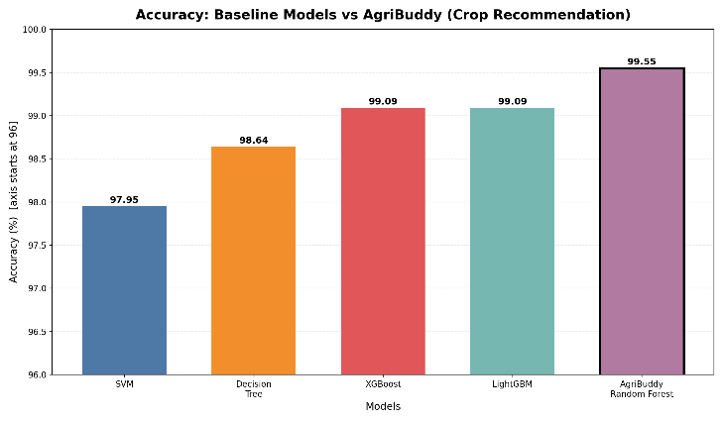

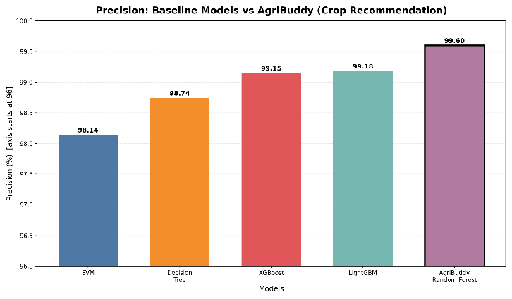

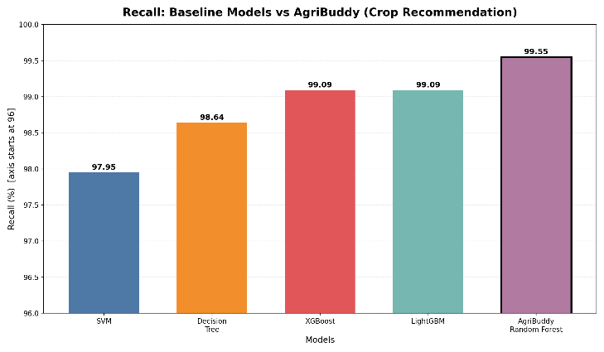

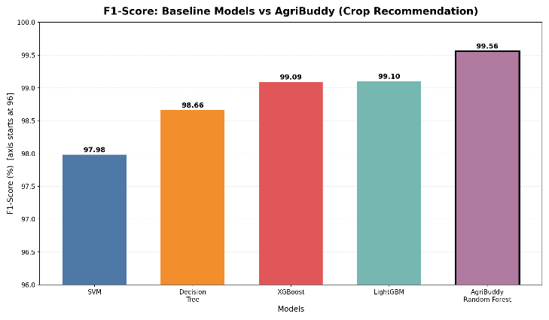
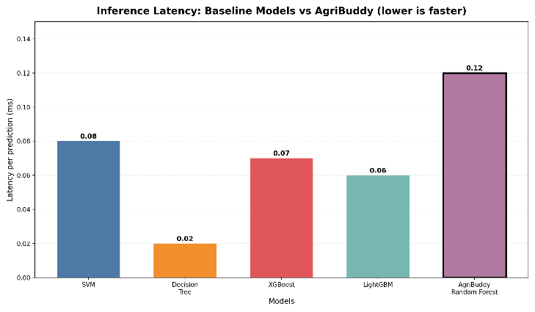

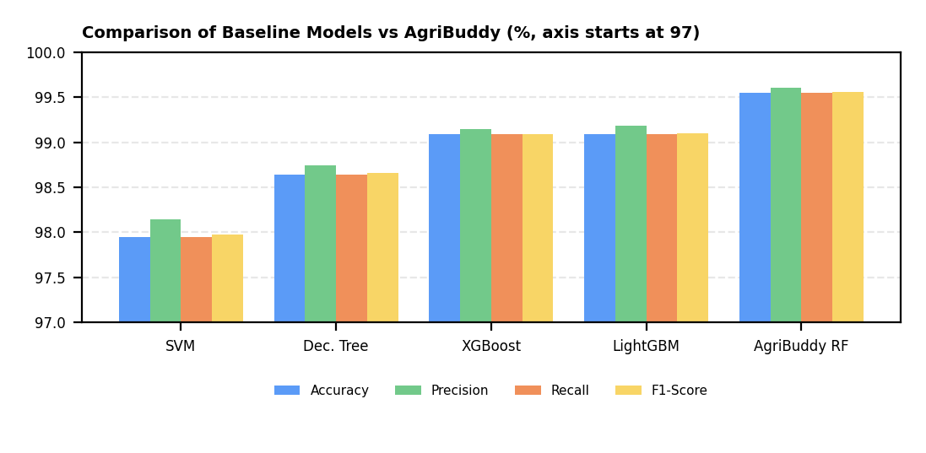

VIII. COMPARISON WITH EXISTING APPROACHES
Table V is a qualitative literature comparison. Results from separate publications are not placed in a numerical leaderboard because they use different corpora, label spaces, and splits.
TABLE V. QUALITATIVE COMPARISON WITH REPRESENTATIVE APPROACHES.
Approach / reference | Focus | Relation to this platform
Crop recommendation for Indian agriculture [1] | Soil/climate-based crop selection | Related single-task system; not re-run here
Smart farm management with ML [2] | Data-driven crop and resource management | Related integrated scope; not re-run here
Crop recommendation with ML [3] | Crop selection under changing conditions | Related comparator; not re-run here
PlantVillage [5] | Labelled leaf-image data | Source family for the 32-class task
Random Forest / XGBoost / LightGBM [6]–[8] | Tabular learners | Algorithms compared in this work
FAO-56 [9] | Crop water requirement | Basis of the irrigation module and its labels
This platform | Four tasks, image validation, three languages | Metrics recorded on curated/project data; field validation pending

Table VI states the intended methodological difference without claiming unmeasured advantages.
TABLE VI. DESIGN COMPARISON: CONVENTIONAL WORKFLOW VS. THIS PLATFORM.
Dimension | Conventional workflow | This platform and evidence status
Task scope | Separate tools per task | Four modules in one platform; metrics recorded per task
Model choice | One algorithm picked early | Five algorithms compared on a shared split; differences are small
Input quality | Images accepted as-is | Vegetation and blur filters; error rates not yet measured
Language access | Often English only | English, Telugu, Hindi; usability not user-tested
Irrigation basis | Rule of thumb | FAO-56 based; not validated on field data
Verification | Accuracy alone reported | 42 passing software tests; agronomic validity not established
Reproducibility | Metrics without configuration | Split ratio, seed, dataset sizes, and hardware to be stated
Comparison validity | Results across papers juxtaposed | Qualitative review kept separate from local metrics

IX. DISCUSSION
Ensemble methods performed best on both classification tasks, and the narrow spread on crop recommendation suggests the seven features separate the 22 classes cleanly. The recorded accuracies are consistent with a test set of about 440 records (a 20% split), in which case the 0.46-point lead of Random Forest over LightGBM and XGBoost corresponds to only about two records . Differences this small should not be read as a firm ranking without repeated splits or cross-validation. The 3.5-point gap between Decision Tree and Random Forest on the disease task is larger, but a per-class analysis is needed to see where errors occur.
For regression, XGBoost was slightly better than Random Forest on both tasks. Since irrigation labels follow FAO-56 and the yield data are project-generated, the high R² values are evidence of internal consistency only.
The broader hypothesis is that an integrated, multilingual platform with input validation is more useful to farmers than separate tools. Testing it requires: (i) validation of irrigation and yield models on field-measured data, (ii) disease accuracy on real field photographs with a per-class confusion matrix, (iii) false-accept and false-reject rates of the image filters, (iv) cross-validated or repeated-split metrics with confidence intervals, (v) performance on unseen regions and seasons, and (vi) farmer and expert usability trials. Each result should be tied to a run ID, configuration, random seed, dataset checksum, and label mapping.
X. THREATS TO VALIDITY
Dataset and split validity: the split ratio and seed are not yet stated, and near-duplicate or augmented leaf images may cause leakage across splits.
Label validity: irrigation labels follow FAO-56 and yield labels come from project datasets, so the targets are not independent field measurements.
Metric validity: the yield accuracy (within 15%) is non-standard and must be read with MAE, RMSE, and R². Weighted averages can hide weak minority classes.
Domain shift: curated images and a public tabular dataset may not represent field photographs or thinly represented crops, regions, seasons, and soils.
Simulated components: no physical soil sensors were connected (the dashboard uses a microclimate simulation), the external Gemini service was off so the assistant used the built-in offline knowledge model, and marketplace payment is not implemented.
Testing validity: the 42 tests are functional and do not measure prediction correctness.
Literature comparison: published systems use different datasets and protocols, so Table V is qualitative and not a ranking.
Incomplete validation: field validation, per-class confusion analysis, filter error rates, and cross-region testing are not claimed as completed findings. The system supports decisions and does not replace agronomists; advice should be checked against local guidance before it affects crop or water management.
XI. CONCLUSION AND FUTURE WORK
This paper presented a modular ML platform for crop recommendation, leaf-disease classification, irrigation estimation, and yield forecasting delivered through a multilingual web application. Random Forest gave the best crop (99.55%) and disease (97.81%) results, XGBoost gave the lowest irrigation and yield errors, and all 42 automated tests passed. These figures are reported transparently but describe curated and project datasets, not field performance.
The most important next steps are connecting live IoT soil sensors, validating the irrigation and yield models on field-collected data, and testing the disease classifier on real field photographs with a per-class confusion analysis. Further work includes repeated-split evaluation, measuring the image-filter error rates, adding explainable predictions, enabling the external language-model service, and running field trials with agricultural experts and farmers. Only after these are run and documented should stronger claims about real-world accuracy or usefulness be made.
CONFLICT OF INTEREST
The author(s) declare(s) that there is no conflict of interest regarding the publication of this paper.
ACKNOWLEDGMENT
The authors thank the Department of Computer Science and Engineering, Koneru Lakshmaiah Education Foundation, for its support.
REFERENCES
[1] "Leveraging Artificial Intelligence and Machine Learning for Enhanced Crop Yield: A Crop Recommendation System for Indian Agriculture," in Proc. 2023 Int. Conf. IoT, Communication and Automation Technology (ICICAT), 2023, doi: 10.1109/ICICAT57735.2023.10263734.
[2] "Smart Farm Management Using Machine Learning," in Proc. 2024 Int. Conf. IoT, Communication and Automation Technology (ICICAT), 2024, doi: 10.1109/ICICAT62666.2024.10923013.
[3] "Agriculture Crop Recommendation System Using Machine Learning," in Proc. 2024 Int. Conf. Advancements in Smart, Secure and Intelligent Computing (ASSIC), 2024, doi: 10.1109/ASSIC60049.2024.10507899.
[4] THUDM, "Crop Recommendation Dataset," Hugging Face Datasets. [Online]. Available: https://huggingface.co/datasets/THUDM/Crop_recommendation. Accessed: Oct. 29, 2026.
[5] D. P. Hughes and M. Salathé, "An open access repository of images on plant health to enable the development of mobile disease diagnostics," arXiv:1511.08060, 2015.
[6] L. Breiman, "Random forests," Machine Learning, vol. 45, no. 1, pp. 5–32, 2001.
[7] T. Chen and C. Guestrin, "XGBoost: A scalable tree boosting system," in Proc. 22nd ACM SIGKDD Int. Conf. Knowledge Discovery and Data Mining, 2016, pp. 785–794.
[8] G. Ke et al., "LightGBM: A highly efficient gradient boosting decision tree," in Advances in Neural Information Processing Systems 30, 2017, pp. 3146–3154.
[9] R. G. Allen, L. S. Pereira, D. Raes, and M. Smith, "Crop evapotranspiration—Guidelines for computing crop water requirements," FAO Irrigation and Drainage Paper 56, Food and Agriculture Organization, Rome, 1998.

